<https://en.wikipedia.org/wiki/Generative_adversarial_network>

<https://www.analyticsvidhya.com/blog/2019/04/top-5-interesting-applications-gans-deep-learning/>

# **Generative adversarial network**

A **generative adversarial network** (**GAN**) is a class of [machine learning](https://en.wikipedia.org/wiki/Machine_learning) systems invented by [Ian Goodfellow](https://en.wikipedia.org/wiki/Ian_Goodfellow) and his colleagues in 2014.[[1]](https://en.wikipedia.org/wiki/Generative_adversarial_network#cite_note-GANnips-1) Two [neural networks](https://en.wikipedia.org/wiki/Neural_network) contest with each other in a game (in the sense of [game theory](https://en.wikipedia.org/wiki/Game_theory), often but not always in the form of a [zero-sum game](https://en.wikipedia.org/wiki/Zero-sum_game)). Given a training set, this technique learns to generate new data with the same statistics as the training set. For example, a GAN trained on photographs can generate new photographs that look at least superficially authentic to human observers, having many realistic characteristics. Though originally proposed as a form of [generative model](https://en.wikipedia.org/wiki/Generative_model) for [unsupervised learning](https://en.wikipedia.org/wiki/Unsupervised_learning), GANs have also proven useful for [semi-supervised learning](https://en.wikipedia.org/wiki/Semi-supervised_learning),[[2]](https://en.wikipedia.org/wiki/Generative_adversarial_network#cite_note-ITT_GANs-2) fully [supervised learning](https://en.wikipedia.org/wiki/Supervised_learning),[[3]](https://en.wikipedia.org/wiki/Generative_adversarial_network#cite_note-3) and [reinforcement learning](https://en.wikipedia.org/wiki/Reinforcement_learning).[[4]](https://en.wikipedia.org/wiki/Generative_adversarial_network#cite_note-4) In a 2016 seminar, [Yann LeCun](https://en.wikipedia.org/wiki/Yann_LeCun) described GANs as "the coolest idea in machine learning in the last twenty years".[[5]](https://en.wikipedia.org/wiki/Generative_adversarial_network#cite_note-5)

## Applications[[edit](https://en.wikipedia.org/w/index.php?title=Generative_adversarial_network&action=edit&section=2)]

GAN applications have increased rapidly.[[8]](https://en.wikipedia.org/wiki/Generative_adversarial_network#cite_note-8)

### Fashion, art and advertising[[edit](https://en.wikipedia.org/w/index.php?title=Generative_adversarial_network&action=edit&section=3)]

GANs can be used to create photos of imaginary fashion models, with no need to hire a model, photographer, makeup artist, or pay for a studio and transportation.[[9]](https://en.wikipedia.org/wiki/Generative_adversarial_network#cite_note-9) GANs can be used to create fashion advertising campaigns including more diverse groups of models, which may increase intent to buy among people resembling the models.[[10]](https://en.wikipedia.org/wiki/Generative_adversarial_network#cite_note-10) GANs can also be used to create [portraits, landscapes and album covers](https://www.artbreeder.com/).

### Science[[edit](https://en.wikipedia.org/w/index.php?title=Generative_adversarial_network&action=edit&section=4)]

GANs can [improve](https://en.wikipedia.org/wiki/Image_restoration) [astronomical images](https://en.wikipedia.org/wiki/Astrophotography)[[11]](https://en.wikipedia.org/wiki/Generative_adversarial_network#cite_note-11) and simulate gravitational lensing for dark matter research.[[12]](https://en.wikipedia.org/wiki/Generative_adversarial_network#cite_note-12)[[13]](https://en.wikipedia.org/wiki/Generative_adversarial_network#cite_note-13)[[14]](https://en.wikipedia.org/wiki/Generative_adversarial_network#cite_note-14) They were used in 2019 to successfully model the distribution of [dark matter](https://en.wikipedia.org/wiki/Dark_matter) in a particular direction in space and to predict the [gravitational lensing](https://en.wikipedia.org/wiki/Gravitational_Lensing) that will occur.[[15]](https://en.wikipedia.org/wiki/Generative_adversarial_network#cite_note-15)[[16]](https://en.wikipedia.org/wiki/Generative_adversarial_network#cite_note-16)

GANs have been proposed as a fast and accurate way of modeling high energy jet formation[[17]](https://en.wikipedia.org/wiki/Generative_adversarial_network#cite_note-17) and modeling [showers](https://en.wikipedia.org/wiki/Particle_shower) through [calorimeters](https://en.wikipedia.org/wiki/Calorimeter_(particle_physics)) of [high-energy physics](https://en.wikipedia.org/wiki/Particle_physics) experiments.[[18]](https://en.wikipedia.org/wiki/Generative_adversarial_network#cite_note-18)[[19]](https://en.wikipedia.org/wiki/Generative_adversarial_network#cite_note-19)[[20]](https://en.wikipedia.org/wiki/Generative_adversarial_network#cite_note-20)[[21]](https://en.wikipedia.org/wiki/Generative_adversarial_network#cite_note-21) GANs have also been trained to accurately approximate bottlenecks in computationally expensive simulations of particle physics experiments. Applications in the context of present and proposed [CERN](https://en.wikipedia.org/wiki/CERN) experiments have demonstrated the potential of these methods for accelerating simulation and/or improving simulation fidelity.[[22]](https://en.wikipedia.org/wiki/Generative_adversarial_network#cite_note-22)[[23]](https://en.wikipedia.org/wiki/Generative_adversarial_network#cite_note-23)

### Video games[[edit](https://en.wikipedia.org/w/index.php?title=Generative_adversarial_network&action=edit&section=5)]

In 2018, GANs reached the [video game modding](https://en.wikipedia.org/wiki/Mod_(video_gaming)) community, as a method of [up-scaling](https://en.wikipedia.org/wiki/Image_scaling) low-resolution 2D textures in old video games by recreating them in [4k](https://en.wikipedia.org/wiki/4K_resolution) or higher resolutions via image training, and then down-sampling them to fit the game's native resolution (with results resembling the [supersampling](https://en.wikipedia.org/wiki/Supersampling" \o "Supersampling) method of [anti-aliasing](https://en.wikipedia.org/wiki/Spatial_anti-aliasing)).[[24]](https://en.wikipedia.org/wiki/Generative_adversarial_network#cite_note-24) With proper training, GANs provide a clearer and sharper 2D texture image magnitudes higher in quality than the original, while fully retaining the original's level of details, colors, etc. Known examples of extensive GAN usage include [Final Fantasy VIII](https://en.wikipedia.org/wiki/Final_Fantasy_VIII), [Final Fantasy IX](https://en.wikipedia.org/wiki/Final_Fantasy_IX), [Resident Evil](https://en.wikipedia.org/wiki/Resident_Evil_(2002_video_game)) REmake HD Remaster, and [Max Payne](https://en.wikipedia.org/wiki/Max_Payne).

### Concerns about malicious applications[[edit](https://en.wikipedia.org/w/index.php?title=Generative_adversarial_network&action=edit&section=6)]

[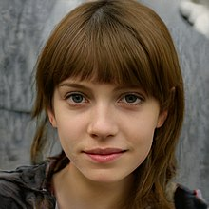](https://en.wikipedia.org/wiki/File:Woman_1.jpg)

An image generated by a [StyleGAN](https://en.wikipedia.org/wiki/StyleGAN" \o "StyleGAN) that looks deceptively like a photograph of a real person. This image was generated by a StyleGAN based on an analysis of portraits.

Concerns have been raised about the potential use of GAN-based [human image synthesis](https://en.wikipedia.org/wiki/Human_image_synthesis) for sinister purposes, e.g., to produce fake and/or incriminating photographs and videos.[[25]](https://en.wikipedia.org/wiki/Generative_adversarial_network#cite_note-TPDNEwuaitcryhf|-25) GANs can be used to generate unique, realistic profile photos of people who do not exist, in order to automate creation of fake social media profiles.[[26]](https://en.wikipedia.org/wiki/Generative_adversarial_network#cite_note-26)

In 2019 the state of California considered[[27]](https://en.wikipedia.org/wiki/Generative_adversarial_network#cite_note-27) and passed on 3 October 2019 the [bill AB-602](https://leginfo.legislature.ca.gov/faces/billTextClient.xhtml?bill_id=201920200AB602) that bans the use of human image synthesis technologies to make fake pornography without the consent of the people depicted and [bill AB-730](https://leginfo.legislature.ca.gov/faces/billTextClient.xhtml?bill_id=201920200AB730), which prohibits distribution of manipulated videos of a political candidate within 60 days of an election were signed by Governor [Gavin Newsom](https://en.wikipedia.org/wiki/Gavin_Newsom). Both bills were authored by Assembly member [Marc Berman](https://en.wikipedia.org/wiki/Marc_Berman). The laws will come into effect in 2020.[[28]](https://en.wikipedia.org/wiki/Generative_adversarial_network#cite_note-CNET2019-28)

DARPA's Media Forensics program studies ways to counteract fake media, including fake media produced using GANs.[[29]](https://en.wikipedia.org/wiki/Generative_adversarial_network#cite_note-29)

### Miscellaneous applications[[edit](https://en.wikipedia.org/w/index.php?title=Generative_adversarial_network&action=edit&section=7)]

GANs that produce [photorealistic](https://en.wikipedia.org/wiki/Photorealistic_rendering) images can be used to visualize [interior design](https://en.wikipedia.org/wiki/Interior_design), [industrial design](https://en.wikipedia.org/wiki/Industrial_design), shoes,[[30]](https://en.wikipedia.org/wiki/Generative_adversarial_network#cite_note-30) bags, and [clothing](https://en.wikipedia.org/wiki/Clothing) items or items for [computer games](https://en.wikipedia.org/wiki/PC_game)' scenes.[[*citation needed*](https://en.wikipedia.org/wiki/Wikipedia:Citation_needed)] Such networks were reported to be used by [Facebook](https://en.wikipedia.org/wiki/Facebook).[[31]](https://en.wikipedia.org/wiki/Generative_adversarial_network#cite_note-31)

GANs can [reconstruct 3D models of objects from images](https://en.wikipedia.org/wiki/3D_reconstruction_from_multiple_images),[[32]](https://en.wikipedia.org/wiki/Generative_adversarial_network#cite_note-32) and model patterns of motion in video.[[33]](https://en.wikipedia.org/wiki/Generative_adversarial_network#cite_note-33)

GANs can be used to age face photographs to show how an individual's appearance might change with age.[[34]](https://en.wikipedia.org/wiki/Generative_adversarial_network#cite_note-34)

GANs can also be used to transfer map styles in cartography[[35]](https://en.wikipedia.org/wiki/Generative_adversarial_network#cite_note-35) or augment street view imagery.[[36]](https://en.wikipedia.org/wiki/Generative_adversarial_network#cite_note-36)

A variation of the GANs are used in training a network to generate optimal control inputs to nonlinear dynamical systems. Where the discriminatory network is known as a critic that checks the optimality of the solution and the generative network is known as an Adaptive network that generates the optimal control. The critic and adaptive network train each other to approximate a nonlinear optimal control.[[37]](https://en.wikipedia.org/wiki/Generative_adversarial_network#cite_note-37)

GANs have been used to visualize the effect that climate change will have on specific houses.[[38]](https://en.wikipedia.org/wiki/Generative_adversarial_network#cite_note-38)

A GAN model called Speech2Face can reconstruct an image of a person's face after listening to their voice.[[39]](https://en.wikipedia.org/wiki/Generative_adversarial_network#cite_note-39)

In 2016 GANs were used to generate new molecules for a variety of protein targets implicated in cancer, inflammation, and fibrosis. In 2019 GAN-generated molecules were validated experimentally all the way into mice.[[40]](https://en.wikipedia.org/wiki/Generative_adversarial_network#cite_note-40)[[41]](https://en.wikipedia.org/wiki/Generative_adversarial_network#cite_note-41)

**Introductory Explanation of GANs**

Right, we have a sense of what GANs can do. But how do they work? What goes on underneath all the wonderful applications this powerful algorithm produces? Let’s understand this using a popular example.

There’s a forger (who creates fake artistry) and an investigator tasked with detecting these fake artworks.

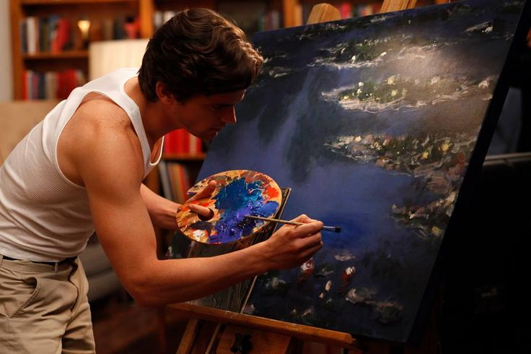

The task of this forger is to create fraudulent imitations of original paintings by famous artists (like Leonardo Da Vinci). If he/she can pass off this work as the original art piece, the forger can potentially net a lot of money.

On the other side of this situation, the art investigator’s task is to catch these forgers. How does he/she do it? The investigator knows what are the properties which set the original artist apart and what kind of painting he/she would have created. The investigator leverages this knowledge against the piece at hand to check if it is real or not.

This contest of forger vs investigator goes on, which ultimately makes world-class investigators (and unfortunately world-class forgers); a battle between good and evil.

Now, consider both forger and investigator as robots. When you train the forger to be a painter and the investigator to tell a  fake painting from the real one – you now have an algorithmic painter at hand! That’s essentially how GANs work on the inside. Awesome, aren’t they?

I haven’t got into the intricate details of GANs here. This is just the tip of the iceberg. If you are interested in learning more about GANs, you should go through this article:

* [An introductory guide to Generative Adversarial Networks (GANs) and their promise!](https://www.analyticsvidhya.com/blog/2017/06/introductory-generative-adversarial-networks-gans/?utm_source=blog&utm_medium=top-5-GANs-applications)

**Applications of GANs**

Now that we have an intuition of how GANs work, let’s put on our exploration hats! It’s time to dive into the interesting applications of GANs that are commonly used in the industry right now.

**GANs for Image Editing**

Most image editing software these days don’t give us much flexibility to make creative changes in pictures. For example, let’s say you want to change the appearance of a 90-year-old person by changing his/her hairstyle. This can’t be done by the current image editing tools out there. But guess what? Using GANs, we can reconstruct images and attempt to change the appearance drastically.

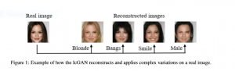

This [amazing paper](https://arxiv.org/pdf/1611.06355.pdf) demonstrates this very cutting edge application.

Another similar application is image de-raining (or literally removing rainy texture from images). Want an example? Check out the below image taken from [this paper](https://github.com/hezhangsprinter/ID-CGAN):

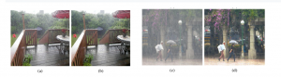

**Using GANs for Security**

The rise of artificial intelligence has been wonderful for most industries. But there’s a real concern that has shadowed the entire AI revolution – cyber threats. Even deep neural networks are susceptible to being hacked.

A constant concern of industrial applications is that they should be robust to cyber attacks. There’s a lot of confidential information on the line! GANs are proving to be of immense help here, directly addressing the concern of “adversarial attacks”.

These adversarial attacks use a variety of techniques to fool deep learning architectures. GANs are used to make existing deep learning models more robust to these techniques. How? By creating more such fake examples and training the model to identify them. Pretty clever stuff.

A [technique called SSGAN](https://arxiv.org/abs/1707.01613) is used to do steganalysis of images and detect harmful encodings which shouldn’t have been there.

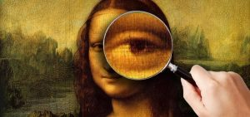

**Generating Data with GANs**

Who among us wouldn’t love to collect more data for building our deep learning model? The availability of data in certain domains is a necessity, especially in domains where training data is needed to model supervideepeeop learning algorithms. The healthcare industry comes to mind here.

GANs shine again as they can be used to generate synthetic data for supervision. That’s right! You know where to go next time you need more data. 🙂

For instance, [this paper](https://arxiv.org/pdf/1612.07828.pdf) explores the creation of synthetic data with the help of GANs for training deep learning algorithms by creating realistic eye images.

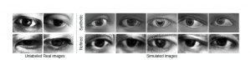

**GANs for Attention Prediction**

When we see an image, we tend to focus on a particular part (rather than the entire image as a whole). This is called attention and is an important human trait. Knowing where a person would look beforehand would certainly be a useful feature for businesses, as they can optimize and position their products better.

For example, game designers can focus on a particular portion of the game to enhance the features and make it more engrossing.

This enthralling idea is explored in [this paper,](https://arxiv.org/pdf/1701.01081) where the authors try to identify the most appealing parts of given images using GANs.

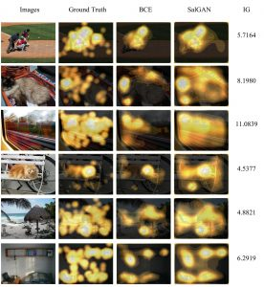

**GANs for 3D Object Generation**

It won’t surprise you to know GANs are quite popular in the gaming industry.

Game designers work countless hours recreating 3D avatars and backgrounds to give them a realistic feel. And let me assure you, it certainly takes a lot of effort to create 3D models by imagination. Does this seem unrealistic? Then I suggest you watch this video. You might believe the incredible power of GANs, wherein they can be used to automate the entire process!

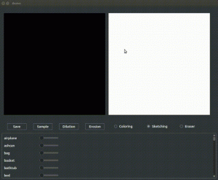

Here is an [open source implementation](https://github.com/maxorange/pix2vox) of the same. Go ahead and try it out if you find the idea interesting!